What are BI (Business Intelligence) Tools?
BI tools are software applications that collect data from different sources, analyze it, and present meaningful insights using charts, tables, dashboards, and reports.
BI tools convert raw data into visual information to support better decisions.

Why BI Tools are Used
- To understand past and current data
- To identify patterns & trends
- To support business & technical decisions
- To monitor performance (KPIs)

How BI Tools Work (Simple Flow)
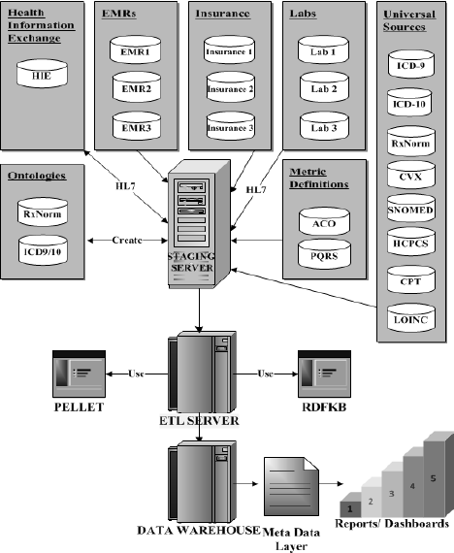
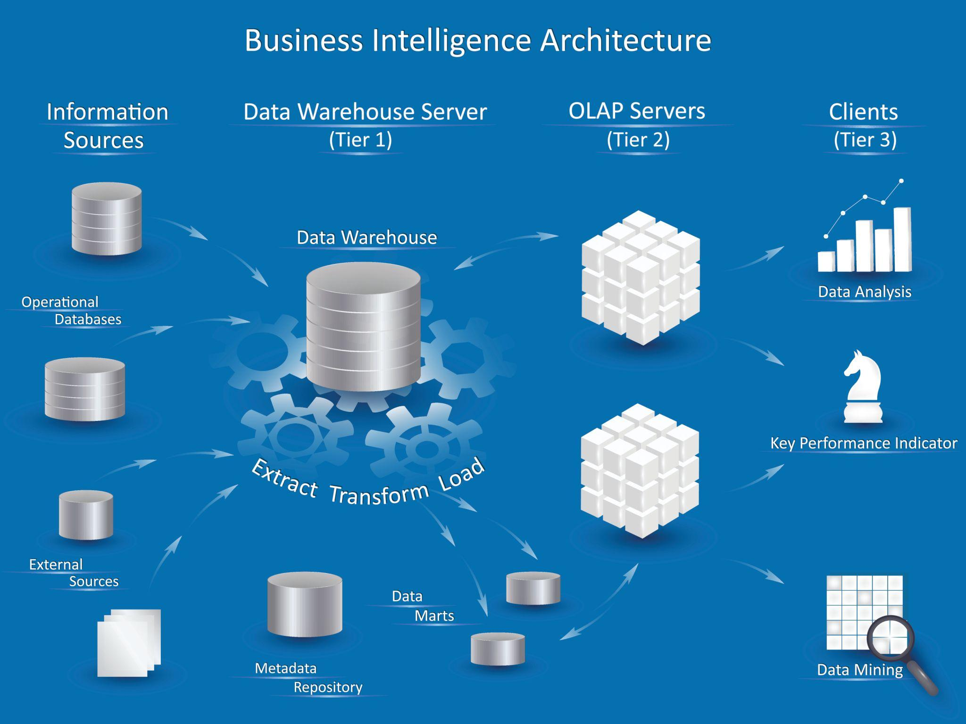
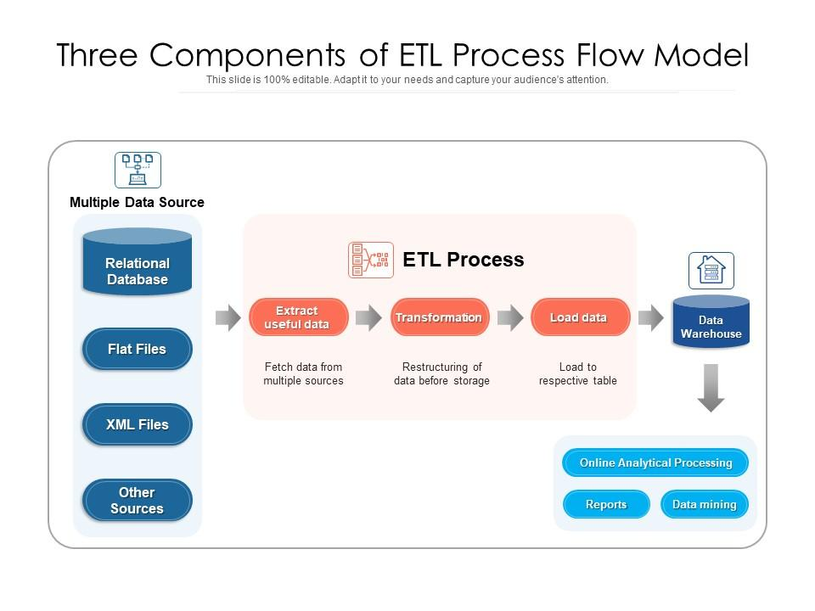
Application / Website / ERP
↓
Databases / Files / APIs
↓
ETL (Extract, Transform, Load)
↓
Data Warehouse
↓
BI Tool (Dashboards & Reports)

Common BI Tools
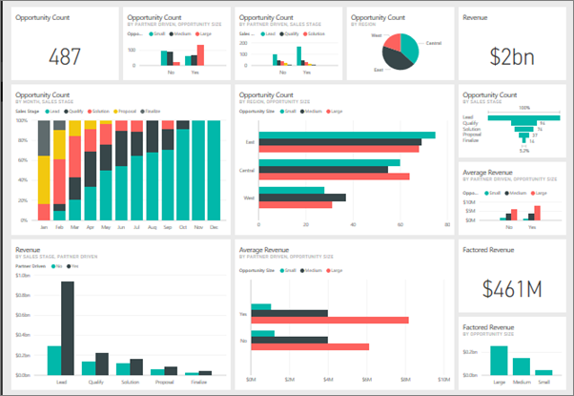
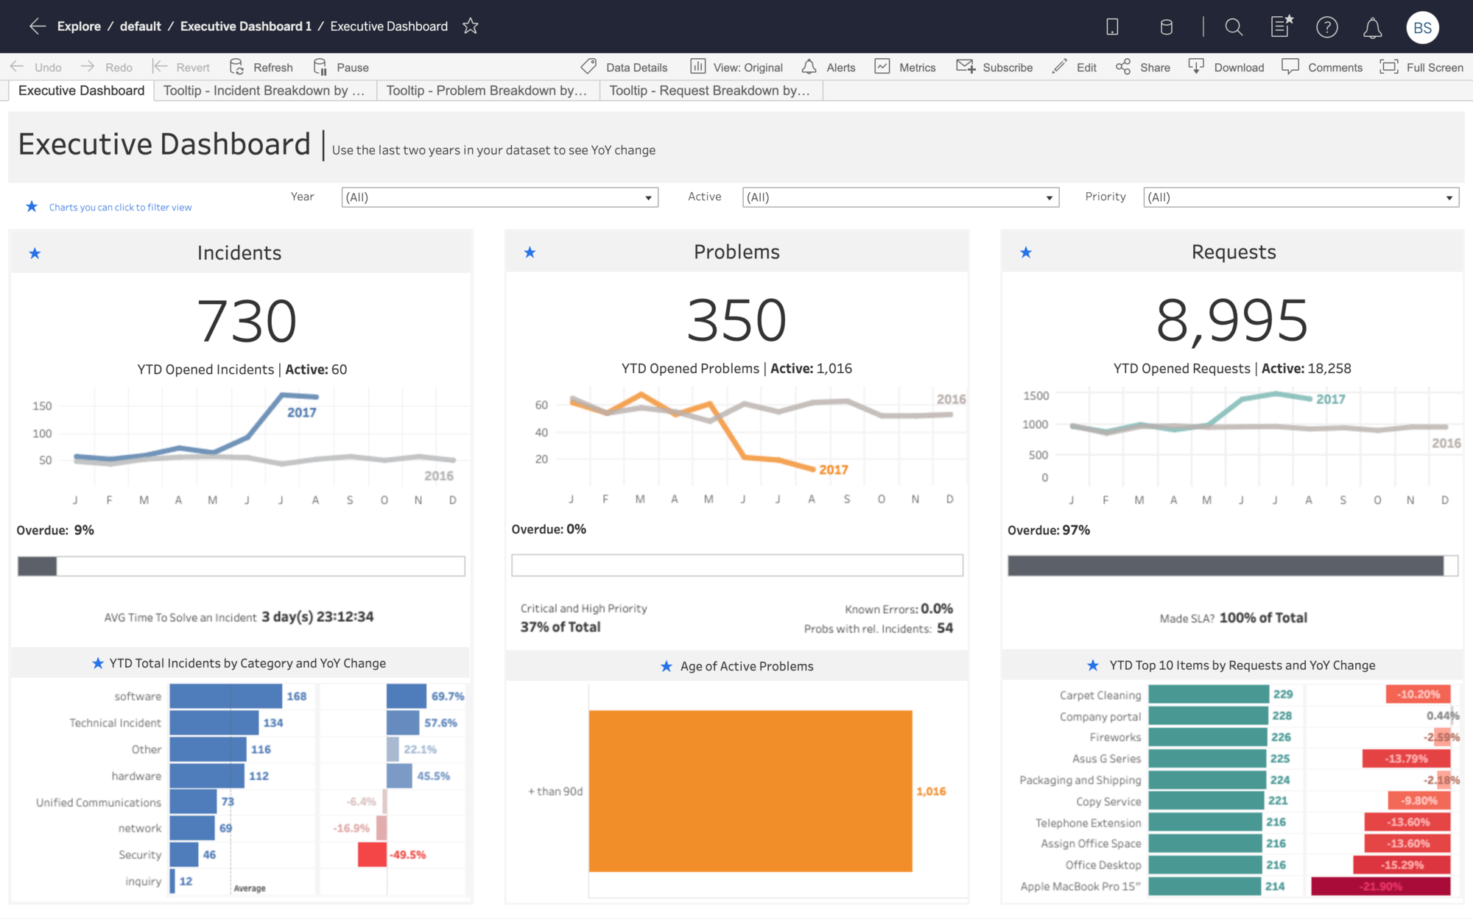
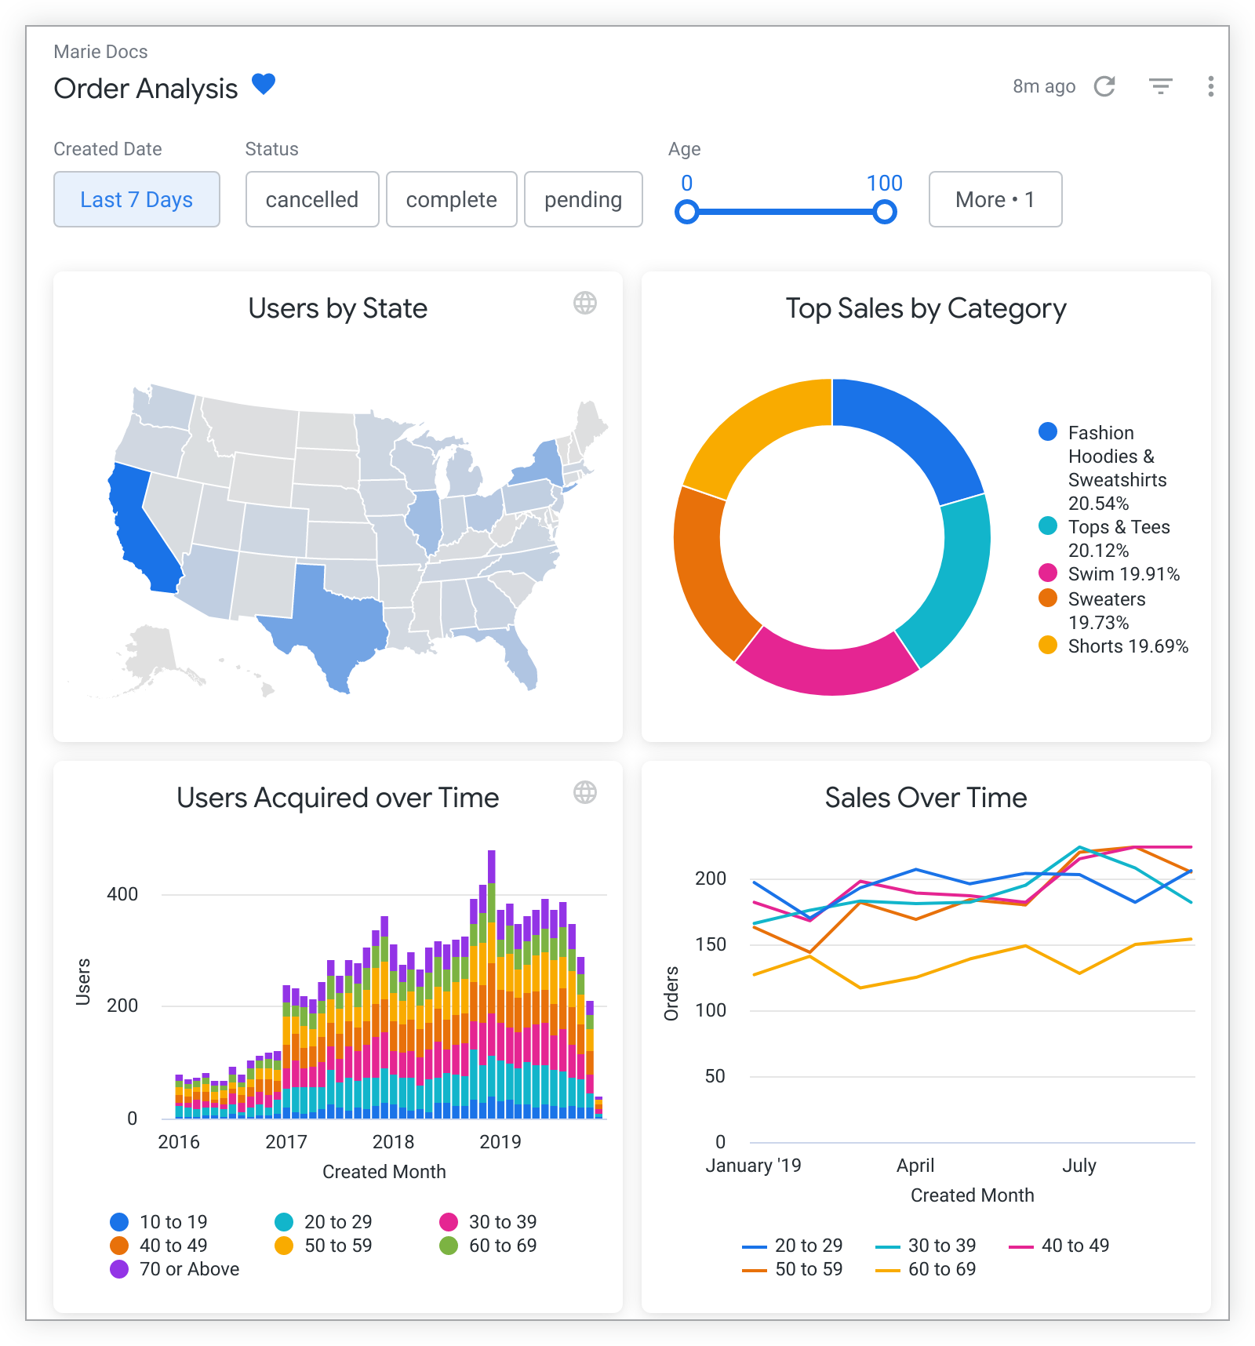

- Power BI
- Tableau
- Looker
- Apache Superset
- Metabase

BI Tool Use Cases with Examples

Sales Analysis
Use Case
- Track daily, monthly, yearly sales
- Compare region-wise or product-wise sales
Example
SELECT product, SUM(amount) AS total_sales
FROM sales
GROUP BY product;

BI Dashboard Shows
- Top-selling products
- Sales trend over time
- Region-wise performance
Helps management decide where to invest more

Customer Behavior Analysis
Use Case
- Understand how users interact with a product
- Identify active vs inactive customers
Example
SELECT COUNT(*) FROM users WHERE last_login >= CURRENT_DATE - 30;
Dashboard Shows
- Active users
- Churn rate
- Popular features
Helps improve user experience

Website / Application Monitoring
Use Case
- Track website visits
- Identify peak usage hours
Example
SELECT visit_date, COUNT(*)
FROM website_logs
GROUP BY visit_date;
Dashboard Shows
- Daily visitors
- Traffic spikes
- Conversion rate
Helps scale infrastructure properly

Finance & Revenue Tracking
Use Case
- Monitor income, expenses, profit
Example
SELECT SUM(revenue) - SUM(expense) AS profit
FROM finance;
Dashboard Shows
- Profit/Loss
- Monthly revenue
- Expense breakdown
Helps in budget planning

Employee / HR Analytics
Use Case
- Track employee count
- Attrition rate
Example
SELECT department, COUNT(*)
FROM employees
GROUP BY department;
Dashboard Shows
- Department-wise employee strength
- Attrition trends
Helps HR planning and hiring decisions

BI Tools vs Traditional Reports
Feature | Traditional Reports | BI Tools
Format | Static | Interactive
Data | Limited | Real-time / Historical
Usage | Manual | Self-service
Visualization | Minimal | Rich dashboards

Real-Life Example (Simple)
E-commerce Application
- Data: Orders, Payments, Users
- BI Tool: Power BI
- Dashboard:
  - Daily orders
  - Revenue per product
  - Customer growth
Owner knows what is selling & what is not

Summary
✔ BI tools analyze historical & current data
✔ They provide dashboards and reports
✔ Used for decision-making
✔ Easy for non-technical users but powerful for engineers

